ETA Representative Assembly
October 18, 2017
Welcome and Call to Order at 4:30pm

- Approval of Agenda
- Approval of Minutes
- Reminder of Robert’s Rules (10 min) – Richard Johnson
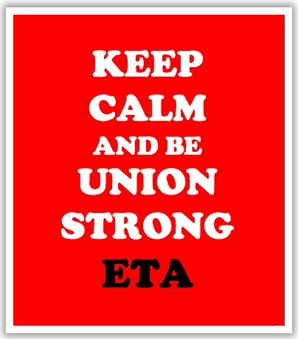
- Training (30 min)
  - Pensions, Tier I, Tier II and Tier III – Jack Janezic
- Issues (20 min) – Richard Johnson
  - 10-minute meeting norms
  - Parent/Teacher Conferences
  - Weingarten/Call me
- Leadership Reports/Updates
  - Region 24 (20 min)
    - GPA – Jen Bury
    - Region Update – Doreen Roberts
  - Officers (20 min)
    - 10-minute meeting – talking points – Jackie Jagielski
    - Those Who Excel – Gary Lorber
    - IEA 4 Phrases – Richard Johnson
- Adjournment 6:30pm

