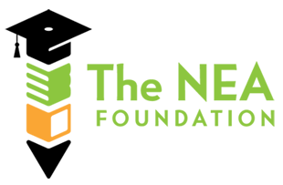

Peer Assistance and Review Plan
for
School District U-46

School District U-46
Elgin Teachers Association
National Education Association Foundation

DRAFT: January 31, 2012

Table of Contents
Background 2
Goals 2
Collaborative Work 3
PAR Team 3
Peer Assistance and Review Stage 1 Plan 4
PAR Panel 4
Teacher Participant 6
Peer Consulting Teacher (PCT) Roles and Responsibilities 6
Minimum Qualifications 6
Job Responsibilities 6
References and Application 7
Term 7
PAR Program Stage 1 Flow Chart 8
PCT Job Description 9

Background

The following report reflects the work of the NEA Foundation Team which began in the summer of 2010 after School District U-46 and the Elgin Teachers Association were selected for a grant from the NEA Foundation Institute for Innovation in Teaching and Learning. Through the collaborative conversations which took place, we are presenting this plan for the Stage 1 implementation of a Peer Assistance and Review Program for U-46.

Goals

School District U-46 and The Elgin Teachers Association (ETA) have a shared interest in making sure that every child has an effective teacher. As What Matters Most, the 1996 report of the National Commission on Teaching and America’s Future, stated: “What teachers know and can do makes the crucial difference in what children can learn.” School District U-46 and the ETA share the common goal of improving student achievement by supporting teachers as they continually build on what they know and what they do inside the classroom. To meet this goal, U-46 and the ETA have worked together to create and support an award-winning Teacher Mentor Program and a Teacher Appraisal Program based on the work of Charlotte Danielson. Although these programs address and identify the learning needs of many of our teachers, we may still have some struggling teachers who are not effectively serving students. The goal of a Peer Assistance and Review (PAR) program is to fill this gap to assure all students receive the most effective instruction possible.
PAR programs have existed since the 1980’s and have been successfully implemented in several states. In the current NEA report on teacher effectiveness, common goals of successful programs shared these traits:
“All teachers participate in peer review programs that (1) furnish the support needed for early career teachers to become effective: (2) implement improvement strategies for struggling teachers to become more effective: (3) identify professional learning opportunities for effective teachers to become highly effective: (4) include a process for teaches who are deemed ineffective to be recommended for dismissal.”

Collaborative Work
Fall 2010 – Downers Grove, IL
First NEA Foundation Conference with all school districts selected for NEA Foundation Institute for Innovation in Teaching and Learning grants. The conference allowed us to explore possible projects. A discussion with team continues as we narrow interest to PAR and measures of student growth. We begin to make initial plans to gather district data on students and staff.
Spring 2011 – St. Louis, MO
Team attends NEA conference where other NEA teams review initial plans and give input. Work begins with NEA coach who attends meetings in District to facilitate work and provide resources. We share our final project overview with our NEA partners.
Summer 2011- Washington, DC
NEA provides 2 day conference on PAR. Presentations from Susan Moore Johnson and panel discussions from PAR program participants. Resources shared with a variety of U-46 staff during TAP and administrative meetings.

Fall 2011 – Columbus, OH
NEA Fall conference on Teacher Effectiveness in Ohio supports the team’s work in creating a model for the first stage of PAR in U-46.

Winter 2011
Team meetings in December and January finalize this report.

PAR Team

Hilda Curda ETA Melanie Meidel U-46
Abbie Eklund ETA Nan Ochs U-46
Andrea Erickson U-46 Sylvia Rodriguez U-46
Heather Fodor ETA Tony Sanders U-46
Maryellyn Friel ETA Ushma Shah U-46

Co-Chairs
Kathryn Castle
Dr. Jose Torres

NEA Foundation Coach: Armin Blaufuss

Peer Assistance and Review Stage 1 Plan

The following reflects the working documents to begin the Stage 1 implementation. Included is a description of the Peer Assistance and Review (PAR) Panel which will provide oversight of the program, the role and responsibilities of the Peer Consulting Teacher, and a flowchart indicating the steps of the PAR process.
For the purpose of Stage 1, the team agreed to focus on the needs of 3rd and 4th year teachers who either: 1) receive a summative rating of “Needs Improvement,” or 2) request additional assistance to further develop their teaching practice. If the PAR program has capacity for additional teachers, 2nd year (experienced new teachers who had a mentor for the first year of employment in the district) teachers will also have an opportunity to apply.
We believe this defined group will benefit from additional support in order to move their practice within the current Teacher Appraisal Plan. We also believe that by focusing on this specific group of teachers during Stage 1, we can learn about how to best design subsequent stages of the PAR program for other groups of teachers.

PAR Panel

The PAR Panel will consist of 8 appointed members, four members appointed by ETA and four appointed by District. The Panel will be co-chaired by both groups. In attendance will also be ex-officio members as requested. The selection of the PAR Panel will be completed by February 2012.
The main duty of the Panel will be to manage and determine all operations and processes of the PAR program. The Panel will make its decisions through the consensus process. Consensus is determined when members: 1) can support the decision, 2) will not undermine the decision, and 3) will publicly support the decision. Ultimately a group reaches consensus when all members agree upon a single decision. In consensus, each group member can honestly say:
“I believe that you understand my point of view and that I understand yours. Whether or not I prefer this decision, I support it because it was reached fairly and openly, and it is the best solution for us at this time”
The PAR Panel will establish and maintain a productive and reciprocal relationship with the TAP Oversight Committee as both groups have responsibilities linked to the Teacher Appraisal Plan and teacher performance. This will happen with two-way communication between both groups on a monthly basis along with the recognition that cooperation can enhance and improve the work of both groups. It is recommended that at each meeting of the PAR Panel there is time allocated for any updates from the TAP Oversight Committee. In addition, at each TAP Oversight Committee there is time allocated for PAR Panel updates, including any new processes, procedures, or policies put into place during Stage 1.
During Stage 1 of implementation, the Panel will meet at least monthly to complete the following duties:

- Determine PAR eligibility based on stated criteria.
- Notify Teacher Nominee, Immediate Supervisor, Site Administrator, ETA President, and Human Resources if the Teacher Nominee will be part of PAR for the upcoming school year.
- Match Peer Consulting Teacher (PCT) with Teacher Nominees selected for PAR.
- Monitor, in an ongoing basis, the progress of all PAR participants by reviewing data as described in PCT job description along with additional data that may be applicable.
- Establish and refine operational procedures and necessary documents and forms.
- Establish and communicate additional program guidelines to TAP Oversight Committee, PCT, Administrators and Teacher Participants as needed.
- Develop, maintain, and communicate PAR data with all stakeholders including program satisfaction of the participants, PCT, Administration, the Teacher Participant.
- Oversee PCT program selection, evaluation and training.
- Submit, no less than annually, a report evaluating program recommendations, modifications, and any refinement made to the PAR program.
- Review submitted Professional Development Plans along with summative documents as a result of Needs Improvement rating to determine Teacher participation in PAR.
- Conduct reconsideration of summative rating when an evaluating administrator and PCT reach differing summative ratings.

Teacher Participant

Third or 4th year teachers who receive a summative appraisal rating of Needs Improvement or who self-nominate for this support will be eligible during Stage 1. Second year teachers who had a mentor for the first year of employment in the district may also have an opportunity to apply for this support depending on space available in the PAR program. A teacher who did not have a Needs Improvement ISBE rating can self-nominate to participate in the PAR process through Human Resources or through the ETA. Their participation will be defined through the Professional Development Plan as described in Performance Evaluation Reform Act and TAP. A Teacher Participant will continue to be appraised in the U-46 TAP with their immediate supervisor. The support from the PCT will be documented and shared with the PAR Panel members. At the completion of the TAP cycle, the summative conference will be held with their immediate supervisor as described in the TAP document. Upon completion of the summative conference, the teacher has 15 school days to request a reconsideration of the rating by the PAR Panel. The PAR Panel will conduct a review of the rating through presentation and documentation from both the primary appraiser and the PCT. The PAR Panel will then make the final determination for the summative rating.

Peer Consulting Teacher (PCT) Roles and Responsibilities

Minimum Qualifications

Applicants must be a current full-time certified staff member with five or more years of successful teaching experience, at least three of the most recent in School District U-46. There should be evidence of prior involvement as a leader such as successful committee work, mentoring, cooperating teacher, or provided professional development within school environment. Individuals should have demonstrated an ability to work cooperatively and effectively with colleagues and prior experience working with adult learners is preferred.

Job Responsibilities

- Meet a minimum of 45 hours per semester for observations/discussions with each Participating Teacher.
- Maintain a written log of contacts and specific support given to each Participating Teacher. The log will be shared with the PAR Panel.
- Document all observations, visitations and meetings.
- Meet with the Teacher Participant to discuss the PAR Program, to establish mutually agreed upon performance goals, and develop the assistance plan in partnership with the immediate supervisor. The above-developed plan will be shared with the PAR Panel.
- Develop with Teacher Participant a process for successful completion of the PAR Program. The process will be confidential and non-evaluative.
- Conduct multiple observations of the Teacher Participant during classroom instruction, and provide specific, immediate feedback, after each visit.
- Monitor the progress of the Teacher Participant and shall provide periodic written and/or oral reports to the Teacher and PAR Panel for discussion and review.
- Provide ongoing assistance to the Teacher Participant until he or she concludes that the agreed upon assistance plan is complete.
- Prepare and discuss a final report with the Teacher Participant and submit that final report to the PAR Panel.

References and Application

Each applicant is required to submit three references. All applications and references shall be treated with the strictest confidentiality. Each reference from individuals should reflect specific knowledge of his or her expertise, as follows:
- A reference from a site administrator or immediate supervisor.
- A reference from currently employed U-46 colleague.
- A reference from a teacher who is knowledgeable of applicant’s teaching skills.

Term

- The term for a PAR Peer Consultant Teacher will not be greater than three years.
- A teacher may not be appointed to an administrative position in the District while serving as a PAR Peer Consultant Teacher for one full year after serving as a PAR Peer Consultant Teacher.

PAR Program Stage 1 Flow Chart

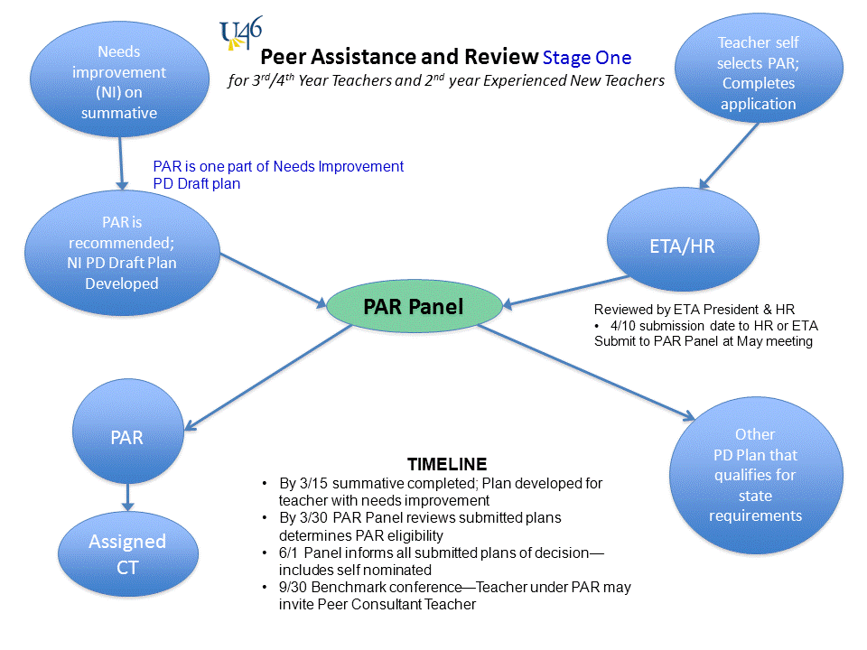
School Year 2011-2012 & 2012-2013

SCHOOL DISTRICT U-46

Job Description
Peer Consultant Teacher
______________________________________________________________________________
JOB DESCRIPTION REVISION DATE: December 1, 2011
DEPARTMENT / SCHOOL: Teacher Effectiveness Initiatives
REPORTS TO: Coordinator for Teacher Effectiveness Initiatives
SUPERVISES: Not Applicable
POSITION GOAL:
To monitor and support Participating Teachers identified for Peer Assistance through ongoing observations, visitations, and discussions with the intent of accelerating the growth of the Participating Teachers' professional practice for the enhancement of student learning.
ESSENTIAL FUNCTIONS:
- Must be a current full-time certified staff member with five or more years of successful teaching experience, the three most recent years in School District U-46.
- Meet with the Referred Participating Teacher to discuss the PAR Program, to establish mutually agreed upon performance goals, and develop the assistance plan.
- Develop with Participating Teacher process for successful completion of the PAR Program. The process will be confidential and non-evaluative.
- Conduct a minimum of 5 observations per semester of the Participating Teacher during classroom instruction, and provide specific, immediate feedback, after each visit.
- Maintain a written log of contacts and specific support given to each Participating Teacher.
- Monitor the progress of the Participating Teacher and shall provide periodic written and/or oral reports to the Participating Teacher for discussion and review.
- Prepare and discuss reports to share with PAR Panel.
- Maintain high level of confidentiality.
- Travel to school sites to work with participating teachers.

KNOWLEDGE AND CRITICAL SKILLS:
- Show a personal and professional attitude of ethics and integrity.
- Focus on solving conflict; maintaining confidentiality; remaining open to others' ideas and contributing to building a positive team spirit.
- Exemplary teaching ability, as indicated by among other things: effective communication skills, subject matter knowledge, and mastery of a range of teaching and classroom management strategies necessary to meet the needs of pupils in different contexts.
- Demonstrate, through professional experience, qualities of leadership, communication skills, community- school relations and school improvement.
- Manage time and resources effectively, work within established timelines, and produce work that reflects a high level of quality.
- Productive and organized in a collaborative environment.

EXPERIENCE AND EDUCATION:
- Thorough understanding of the Framework for Teaching demonstrated by successful completion of the Teacher Mentor Program, Teacher Mentor program mentor training, or serving as a Teacher Appraisal Plan trainer.
- Prior experience as a leader (successful committee work, mentor, cooperating teacher, etc.) within school environment.
- Prior experience working with adult learners is preferred.
- Demonstrated ability to work cooperatively and effectively with colleagues.

Comments:

ENVIRONMENTAL CONDITIONS:
- Able to work in fast pace environment with numerous interruptions.
- Professional attire required.

PHYSICAL DEMANDS:
- While performing the duties of this job, the employee is regularly required to talk or hear.
- The employee is frequently required to walk; sit; use hands for fine manipulation, handle or feel and reach with hands and arms using a keyboard and video display terminal.
- The employee is occasionally required to stand and stoop, kneel, or crouch.
- The employee must regularly lift and/or move up to 10 pounds and occasionally up to 25 pounds.
- Specific vision abilities required by this job include close vision.

ADA:
The employer will make reasonable accommodations in compliance with the Americans with Disabilities Act of 1990.

This job description will be reviewed periodically as duties and responsibilities change with business necessity. Essential and marginal job functions are subject to modification.

TERMS OF EMPLOYMENT:
189 day count calendar (maximum of three consecutive '1 year only' type contract)
The term for a PAR Peer Consultant Teacher will not be greater than three years.
A teacher may not be appointed to an administrative position in the District while serving as a PAR Peer Consultant Teacher for one full year after serving as a PAR Peer Consultant Teacher.

EVALUATION:

Evaluations will be done in accordance to the Elgin Agreement.
Employee Signature: ________________________________ Date: _____________
Supervisor Signature: ________________________________ Date: _____________

National Commission on Teaching and America’s Future, What Matters Most: Teaching for America’s Future. NY, 1996.
Commission on Effective Teachers and Teaching, Transforming Teaching: Connecting Professional Responsibility with Student Learning (A Report to the NEA). Washington, DC, 2011.

